
[NAME OF THE BOOK]
EDITOR NAMES

YEARS
LOCATION

[***INSIDE FRONT COVER.***]

[***FIRST PAGE OF TEXT. IT WILL BE ON THE RIGHT SIDE OF THE SPINE AFTER THE FRONT INSIDE COVER.***]

NAME OF BOOK // ORGANIZATION NAME
Copyright © CURRENT YEAR by the individual authors.

FUNDING, MATERIAL SOURCES & ACKNOWLEDGEMENTS.

Editor: NAMES
Designer: NAMES
Copy Editor: NAMES
Other Credits: NAMES
ISBN: ###
[In order to apply for an ISBN number in Canada, you need to apply for an
ISBN Account from here:
https://www.canada.ca/en/library-archives/services/publishers/isbn/apply.html]

NAME OF BOOK
YEARS
LOCATION
NAME OF INTRODUCTORY ESSAY
WRITER NAME
The material in this publication documents the history and activities of an artist-run organization. This introductory essay should provide context for the photographs, texts, correspondence, ephemera, or other archival materials gathered here. Rather than offering a definitive history, the essay might describe the conditions in which the organization emerged, the people who sustained it, the ideas that shaped it, or the communities that formed around it. It may also address the organization’s internal tensions, changes in direction, and eventual transformation or closure (if applicable).
Possible Questions to Address

- When, where, and why was the organization founded?
- Who initiated it, and who became involved over time?
- What artistic, political, social, or economic conditions influenced its formation?
- What needs did the organization seek to address?
- How did it define its mission, formally or informally?
- How was the organization structured and how were decisions made?
- How were exhibitions, performances, publications, screenings, or other programs developed?
- Was the organization funded? If so, how did financial conditions shape its activities?
- What kinds of labor—paid, unpaid, visible, or invisible—sustained the organization?
- Who participated in its programs, and who made up its audience?
- What relationships did it have with artists, neighbourhoods, institutions, funders, and other artist-run initiatives?
- What conflicts, exclusions, failures, or contradictions were part of its history?
- How did the organization change over time?
- What led to its closure, transformation, or continuation?
- What influence did it have on the wider cultural community?
Possible Roundtable Discussion

You many wish to include an edited roundtable discussion with founders, staff members, artists, volunteers, board members, neighbours, audience members, or other participants who can introduce multiple perspectives into the publication. The discussion does not need to produce a single, unified account.

Disagreements, gaps in memory, and conflicting interpretations may be as historically useful as points of consensus. The following questions are intended to help future researchers understand both the organization and the lived experience of participating in it.
To help ensure that everyone involved feels accurately and fairly represented, participants should be invited to review their responses in the context of the full edited discussion. They should have the opportunity to clarify, revise, or withdraw their comments before publication. The intention is to obtain each participant’s informed approval of the final text.

Possible Questions to Ask

- How did you first get involved with the organization?
- What were you looking for from the organization?
- What did the organization offer the community?
- Who did you see as the community?
- Where did the organization sit within the broader media arts ecology?
- How was the organization structured?
- How were responsibilities divided among those involved?
- What was it like collaborating with the other organization members?
- What worked well and what didn’t?
- Were there tensions, conflicts, or disagreements within the organization?
- How were they handled/resolved?
- What were some of the organization’s strengths?
- What were some of its failures, limitations, or missed opportunities?
- Were there artists, communities, or practices that the organization failed to include?
- How accessible was the organization to artists, audiences, volunteers, and the broader public?
- How was revenue generated?
- What did the finances of the organization look like?
- Were you paid for your work?
- Were artists paid?
- What role did unpaid labour, volunteer work, or informal support play in keeping the organization going?
- How did the organization relate to funders, institutions, galleries, festivals, other artist-run centres, or the wider cultural sector?
- What was your favourite event, program, screening, exhibition, workshop, or moment connected to the organization? Why?
- What led to the organization becoming defunct (if applicable)?
- Why did you leave the organization (if applicable)?
- How did the organization change over time?
- How did your relationship to the organization change over time?
- What traces of the organization remain now? In particular, archives, documentation, relationships, influence, myths, or stories.
- Would you do it again? Why or why not?

[***MAKE SURE SECTION TITLES ARE ON AN EVEN PAGE NUMBER. IF NOT, ADD A BLANK PAGE BEFORE IT.***]

Archival Material

Screenshot of LibreOffice. Credit: Author.

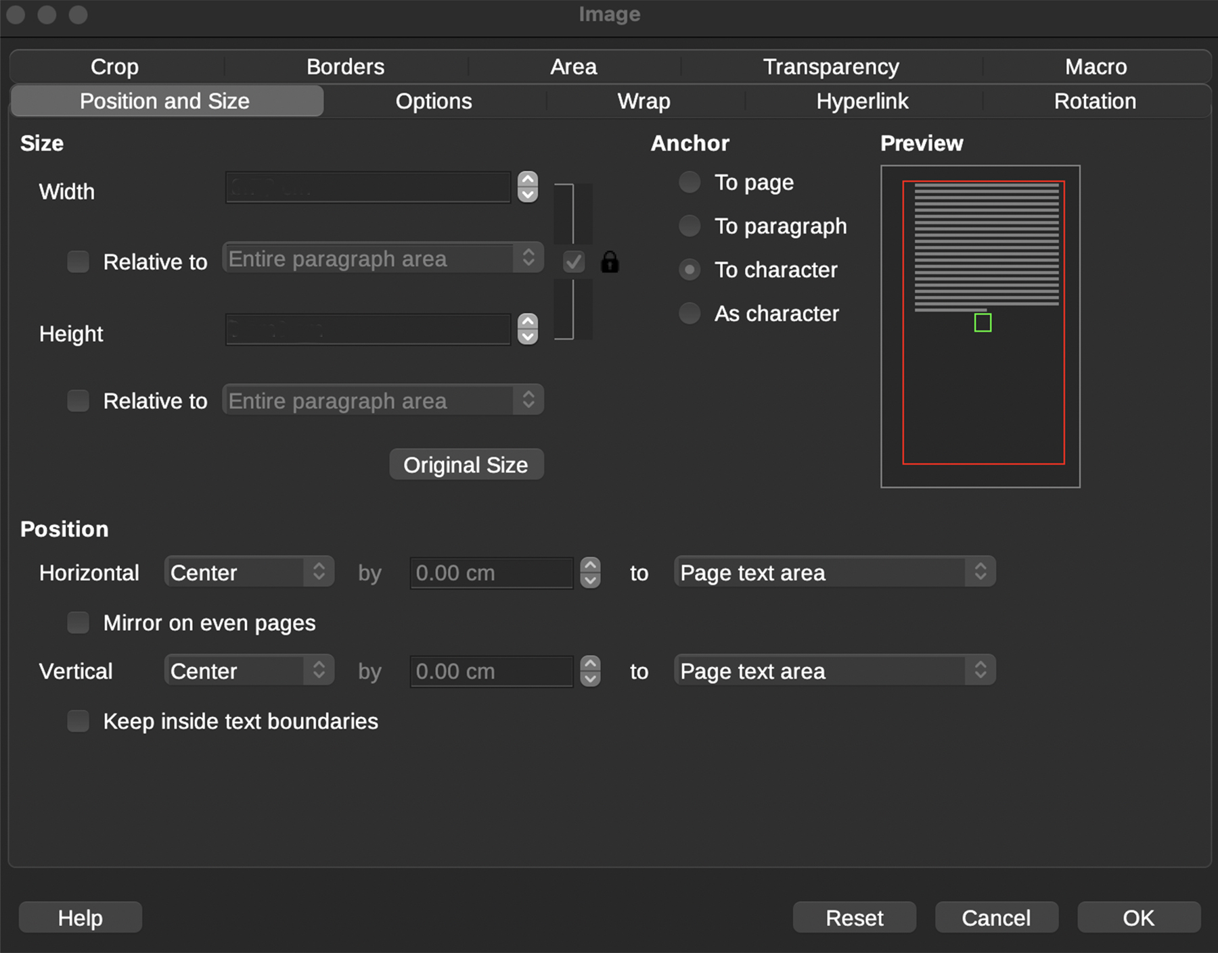
EVENT TITLE
DATE
LOCATION (ADDRESS)
Presented by ORGANIZATIONS
Sponsored by SPONSORS
SHORT PROGRAM DESCRIPTION
Curated by CURATOR
PROGRAM
Notes: NOTE BY THE EDITOR [EVENT INFO OR KNOWN GAPES, ETC.]

NOTES ON IMAGES

Organize all images before placing them into the document. Determine the final sequence in advance and rename each file using a consistent numbering system, for example:

001-IMAGENAME.tiff
002-IMAGENAME.tiff
[...]
Use high-resolution images wherever possible. As a general guideline, prepare each image at 300 dpi, with the longest edge measuring approximately 1800 pixels or 6 inches.

When only low-resolution images are available and larger source files do not exist, they may be carefully upscaled using the following workflow:

Blur -> Size Adjustment -> Sharpen ->
Adjust Colour/Levels/Saturation -> Noise

All adjustments should be subtle. The objective is to improve clarity and reproduction quality without noticeably altering the original image.

AI-based upscaling may also be used, provided that it does not introduce, remove, or modify any visual information. Pay particular attention to text, labels, fine details, and other elements that AI tools may unintentionally distort. Note: the sample logo at the beginning of this document was made using AI and is based on the Film Fort logo.

NOTES ON IMAGE PLACEMENT AND CAPTIONS

Following the screenshot on Page 5.
Size
First ensure that the width and height are locked, by checking the lock attaching them.

For landscape images, choose:
Width: 10.80cm [since height is locked, it will re-adjust.]
For portrait images, choose:
Height: 15.25cm [since width is locked, it will re-adjust.]
This will provide the largest image size that still allows for small captions.
Position
For full page images:
Horizontal Centre to Page text area.
Vertical Centre to Page text area.

For smaller images place the image in the correct location and ensure:
Horizontal Centre to Page text area.
Caption Credits
DESCRIPTION, DATE, MEDIUM. Credit: ARTIST NAME.

Newspaper/Magazine Caption
AUTHOR, “TITLE,” PUBLICATION (DATE PUBLISHED): PAGE NUMBER.
I would also suggest that the relevant text is also typed on on the proceeding or following page.

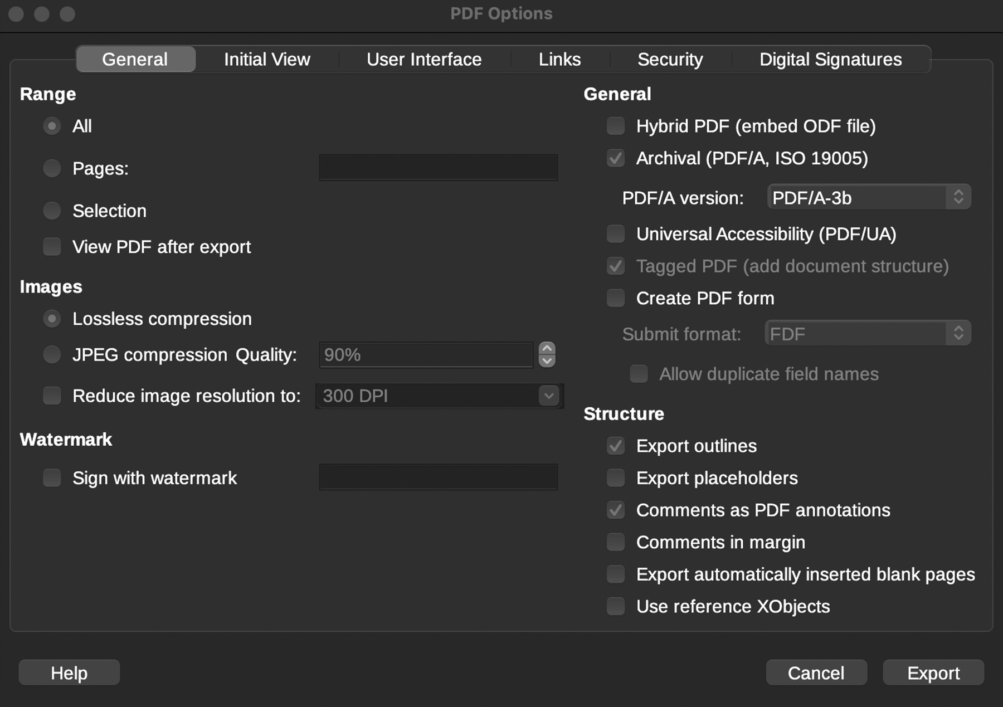
Screenshot of LibreOffice. Credit: Author.

CREATING A PDF

In order to output all of your files as a PDF choose from the main menu:

File -> Export As -> Export as PDF...

Now use the settings on Page 9:
Range
All

Images
Loseless Compression

General
Archival
PDF/A version: PDF/A-3b

[***LAST PAGE OF TEXT. MAKE SURE THIS PAGE IS AN ODD NUMBERED PAGE. IF NOT, ADD A BLANK PAGE BEFORE IT. IT WILL BE ON THE LEFT SIDE OF THE SPINE BEFORE THE BACK INSIDE COVER.***]
[***INSIDE BACK COVER.***]

BACK COVER
Leave this page blank or include images or information you would like to see on the back cover.

